**Project Structure:**

**Form Framework:** Core Php, Separate Database

Query data Save Data Define Schema (the forms and its fields)

**MaMoni Survey :** User control, Categorizing the forms Facility/District etc, using code igniter framework

**Api:** Through http protocols

Output Request Data Request session(login)

**App**

Note:

I think we need to decide upon a general structure for the api request.

**ER Diagram:**

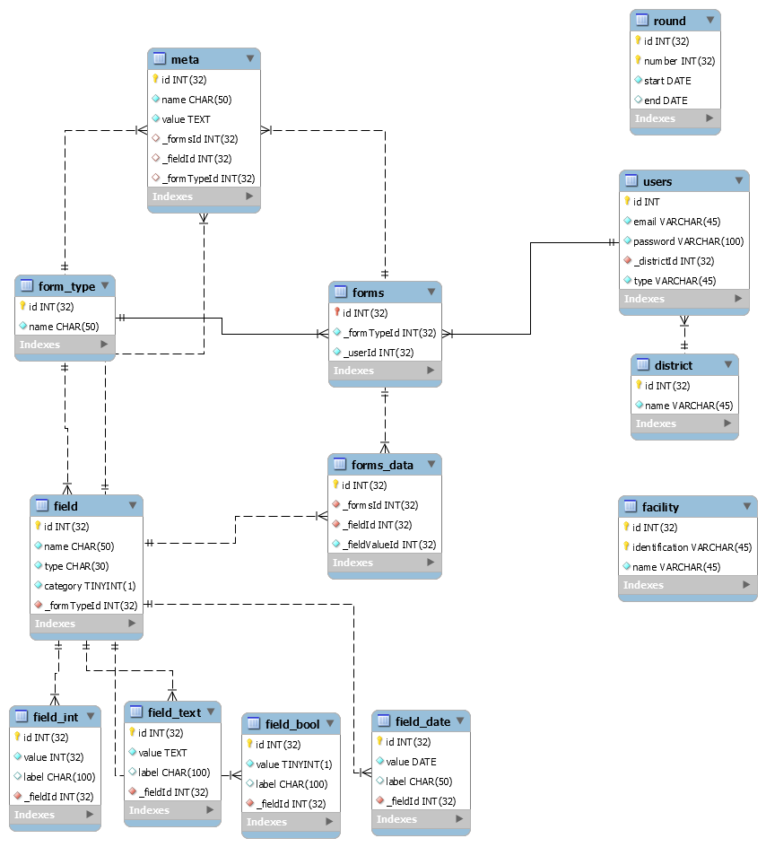

Note: This is a rough layout of the database. There are still some constraints that are missing.